



South Orange Village, New Jersey

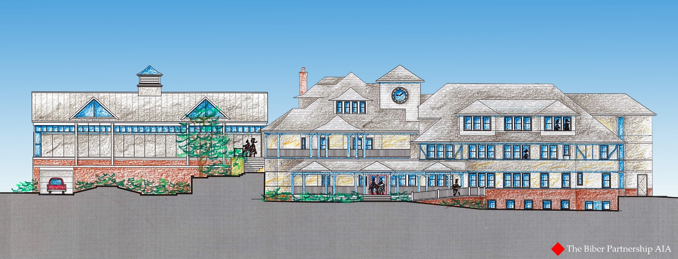
The Baird Community Center PROJECT FACT SHEET November 2022
5 Mead Street, South Orange, New Jersey 07079 Building Renovation and Additions Project
PROJECT SCOPE:
The Baird Community Center was originally constructed in three phases: the first in 1895, the second in 1930 and the third in 1973. The project scope includes the renovation of all existing rooms and porches, replacing the existing roof and adding on a new multi-purpose field house gymnasium.

In addition to the field house, the project will include major renovations to the existing building so it may better serve the community. New arts classrooms will integrate with a new art gallery on the first floor. New dance classrooms are more accessible to children and parents. Numerous multi-purpose spaces will provide valuable community meeting spaces, as well as space for recreation classes and programs for all ages. A performance space and large meeting space on the third floor will support all types of recitals, ensembles and performances and provide a valuable meeting space for town committees and community groups.

As demolition progressed, we uncovered a few historic elements that will be incorporated into the completed project. These features include; 4 fireplaces, original timber beams and columns, roof trusses and the original brick chimney. Improvements will include making the building 100% ADA accessible, new heating and air conditioning throughout, additional restrooms, new elevators, restoring the second-floor porch and adding additional outdoor space for gathering and events. Life safety upgrades include a new fire alarm system and fire sprinkler system along with new fire stairs to replace the aging fire escapes. The exterior will be renovated with a new roof, siding, windows and doors that will make the building more energy efficient and will rejuvenate the Baird’s appearance.

PROJECT TEAM:
Trustees of South Orange Village:
Sheena C. Collum - Village President, Bill Haskins, Donna Coallier, Karen Hartshorn Hilton, Summer Jones, Bobby Brown, and Bob Zuckerman
Village Administrator: Julie Doran, Acting
Town Engineer: Van Cleef Engineering
Purchasing Agent: Ellen Foye-Malgieri
Director of Recreation: Peter Travers
Director of Code Enforcement: Anthony Grenci
Architects: The Biber Partnership
Construction Managers: Jay Shapiro & Associates, Inc.
Construction Contractor: Frankoski Construction

MAJOR MILESTONES:
- Awarded to Frankoski Construction 12/04/2020
- Exterior improvements completed Spring 2023
- New addition completed Spring 2023
- Interior Renovations Completed Spring 2023
- Final Inspections Spring 2023
- Certificate of Occupancy Issue Spring 2023

PROGRESS THIS MONTH:
- General Work Progress: Project is approximately 75% complete. Many structural issues corrected. Exterior wall insulation and sheetrock is underway. Permanent power will occur in mid-December with the delivery of the transformer. Porch waterproofing is another priority issue. Manpower has increased and needs to remain so to complete in Spring.
- Exterior Work: Installation of stucco siding panels to start in December. Completion of storm drainage piping also. Various roofing issues need to be completed.
- Interior Work: Exterior walls on 2nd and 3rd floors have been insulated and are being sheetrocked. Bathrooms are tiled and ceiling installations to start in December. Temporary heat is a critical need.

